C:\Program Files\Microsoft Office\MEDIA\CAGCAT10\j0305493.wmf

Hi!

My name is **Alexandra Petrů**, but everybody calls me **Sasha.**

I´m **13** years old and I was born on **2nd March 2003**.

I live in **Staré Město u Uherského Hradiště** and I attend the school there.

I´m at the **8 class**. My favorite subject at school is **English,** because I think, that it is really useful for future. And I don´t like **Maths, Physics** and **Chemistry**.

My friends are **Natka, Áďa, Lucka** and **Bára**. And my best friend is **Maya.**

I love reading books. My favorite book is **Another day** by **David Levithan**. I also play the flute for six years. I like animals. My favorite animal is **horse**.

I like travelling so much. I was in **Croatia** and **Italy**, but I want to visit **Norway, Spain** and **USA**.

Please Write to my e-mail: **alexpetru@seznam.cz**

Hope to hear from you soon

Bye Sasha

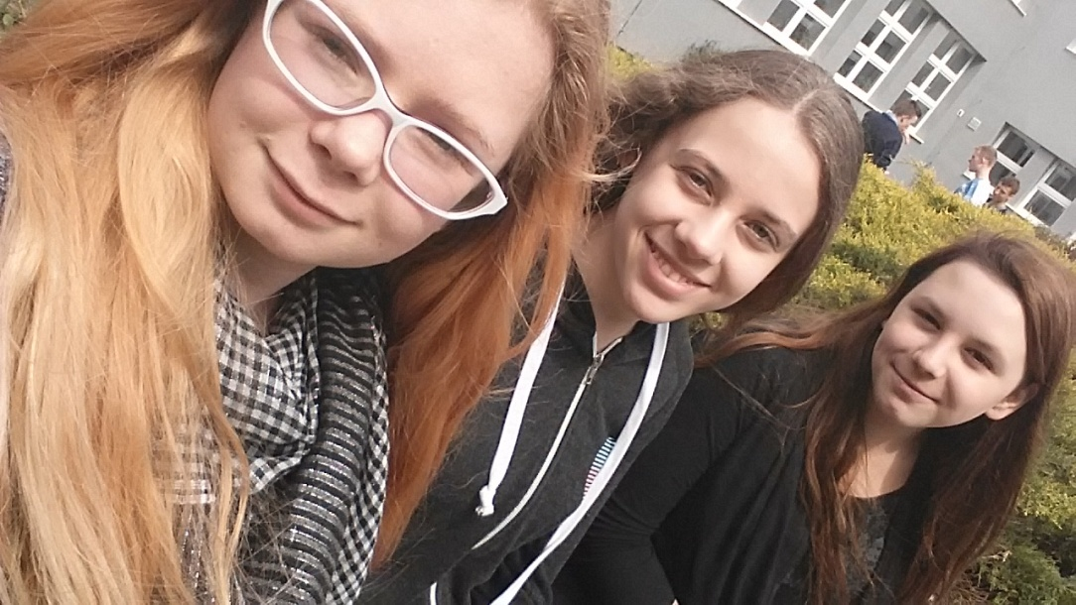 Natka Me Maya